***7ZIP, EPF download manager* must have been installed on your PC before we can run this process.**

* **7ZIP: is a free download and can be downloaded from CNET per ITS**
* **EPF download manager: is available at S:\Skills Portfolio\CCM\NCOA_EPF, along with the instructions pdf**
* **If we do not get the ccmnotify email by last Monday of the month, we will need to contact USPS – The NCOALink Office at 800-589-5766**.

Once your environment is ready with the above, please go through the following steps to implement NCOA.

Last Monday of the month, download is available and can be picked from https://epf.usps.gov

1. An email for the CCM team is generated by USPS in the following format:

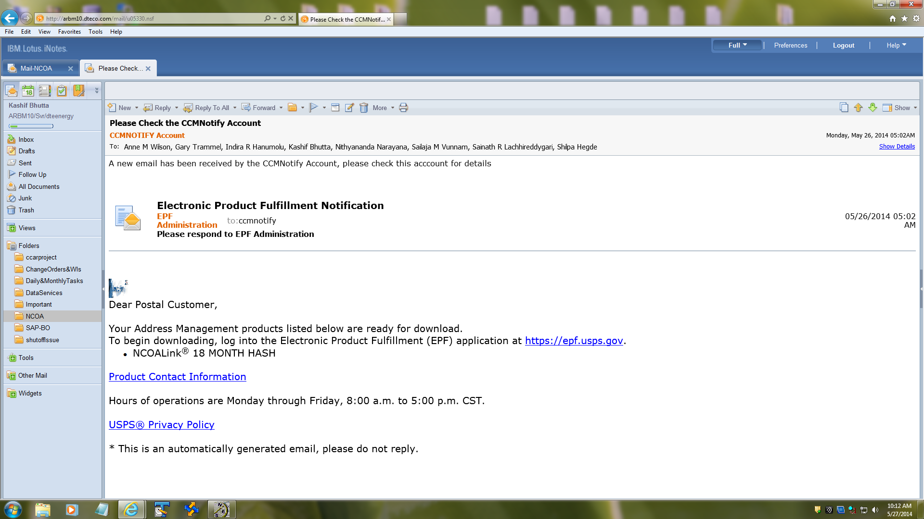

1. After receiving e-mail from usps
2. Login to the EPF download manager
3. From start menu select all programs USPS NCSC
4. Click on epf Download Manager
5. Go to File Login
6. Login credentials: ccmnotify@dteenergy.com/CcM4pd@ncoalink

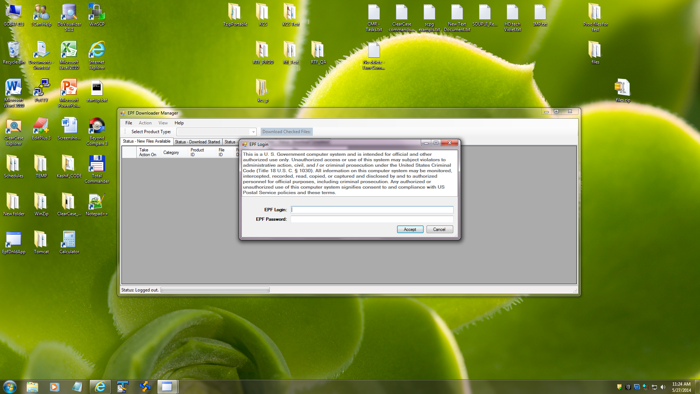

1. After a successful login, pick - NCOA Monthly Products - from the downloadable list

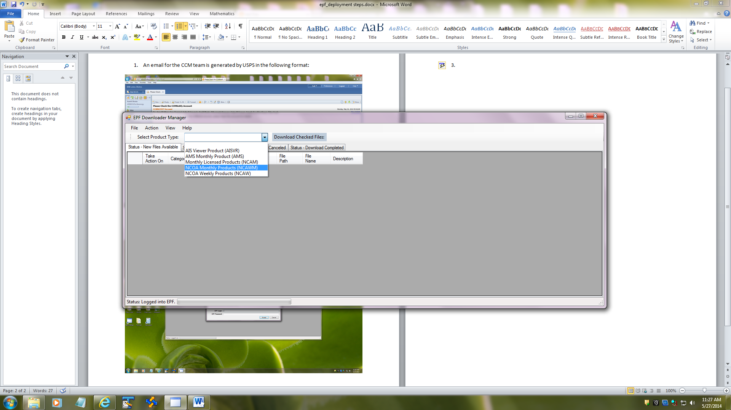

Click on Status – Download Completed tab (You will see the list) select check box the one you want to download

Click on Download Selected Files tab

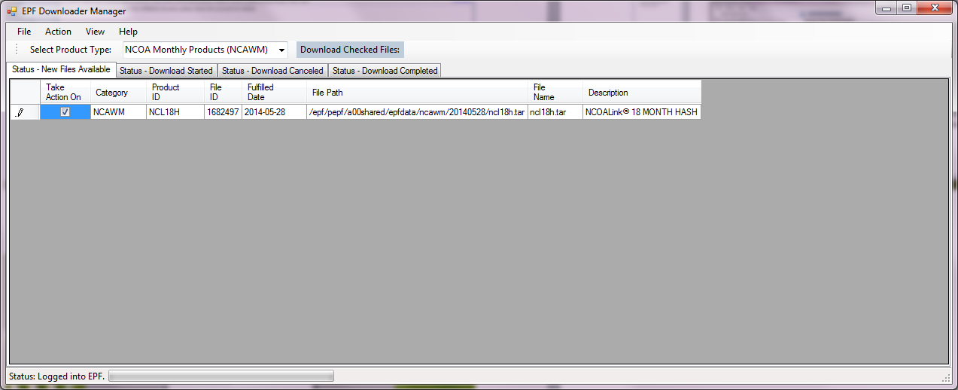

1. Once the download is complete (This will take about 25 minutes) you will see the files downloaded into C:\epfdata\ncl18h.tar

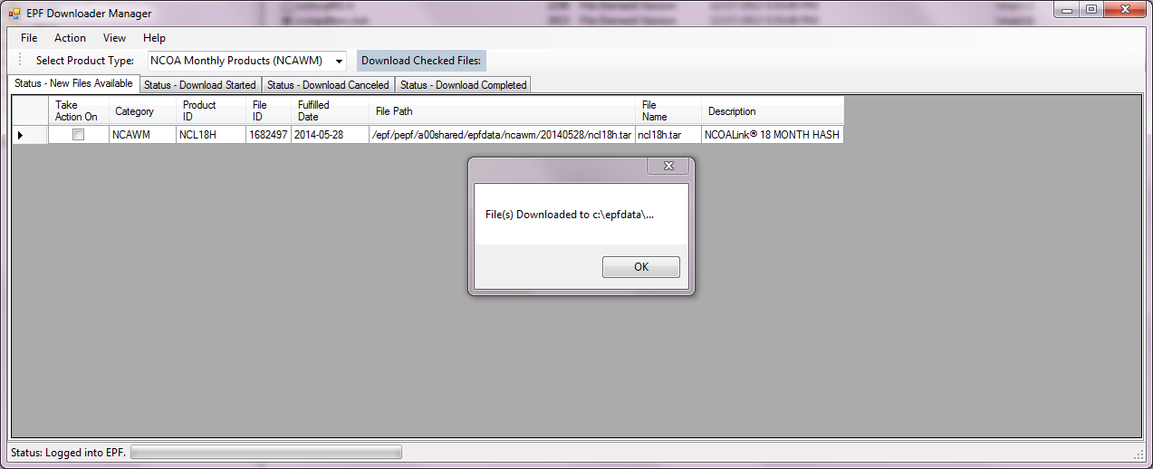

Copy above *.tar file to dca-dev672 E:\opt\temp\(NCOA-Oct0ber2015 example)

1. ***unzip the files using 7ZIP only***. 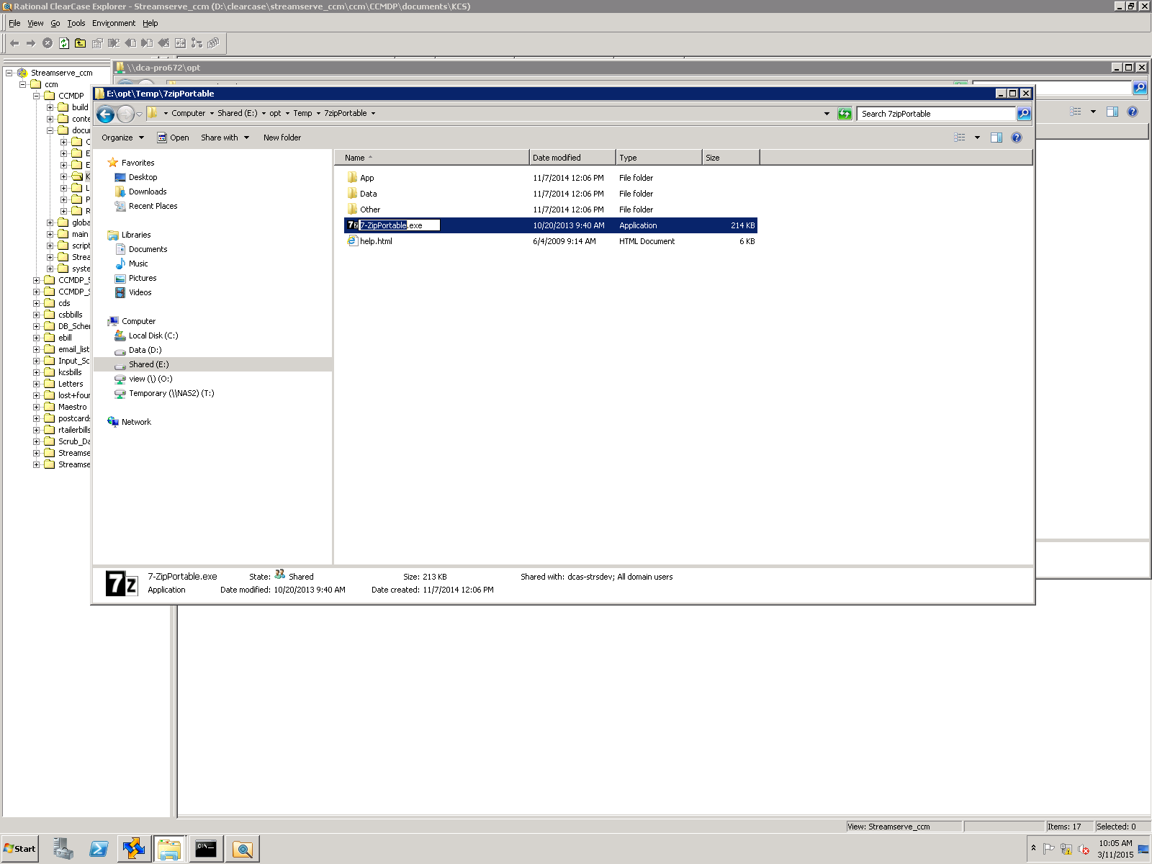

3.Unzip the file using 7-Zip and extract the file.

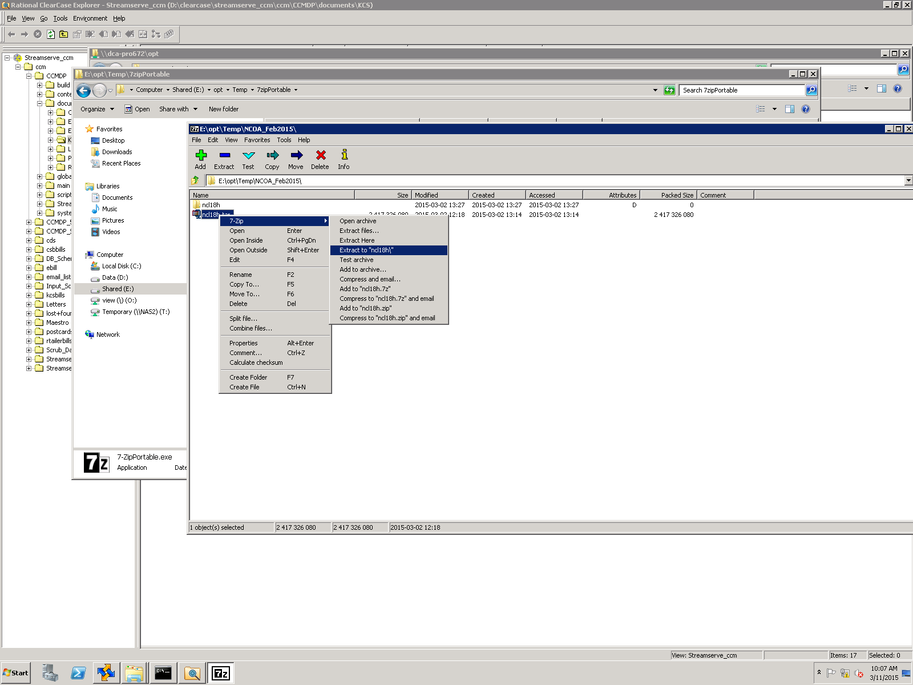

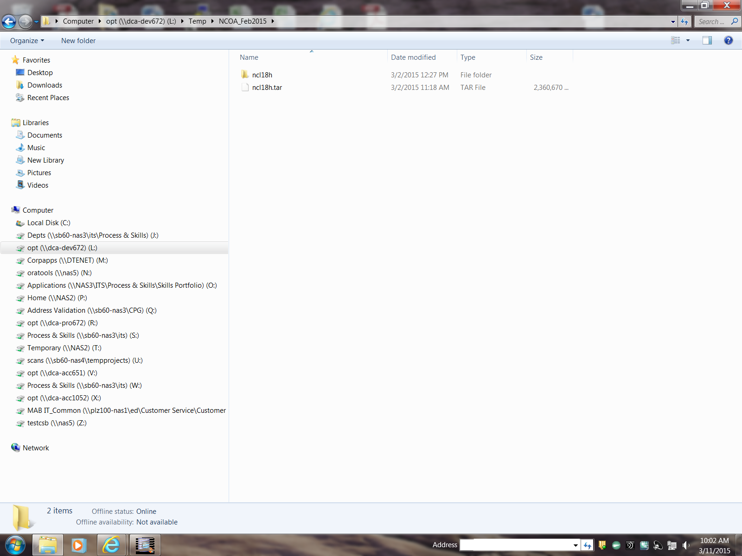

Login to dca-dev672 and delete NCOA-copy folder from D:\ drive. Copy the NCOA folder and paste on Blank place.it should create the folder NCOA-copy or rename the original and paste your local copy in that folder.

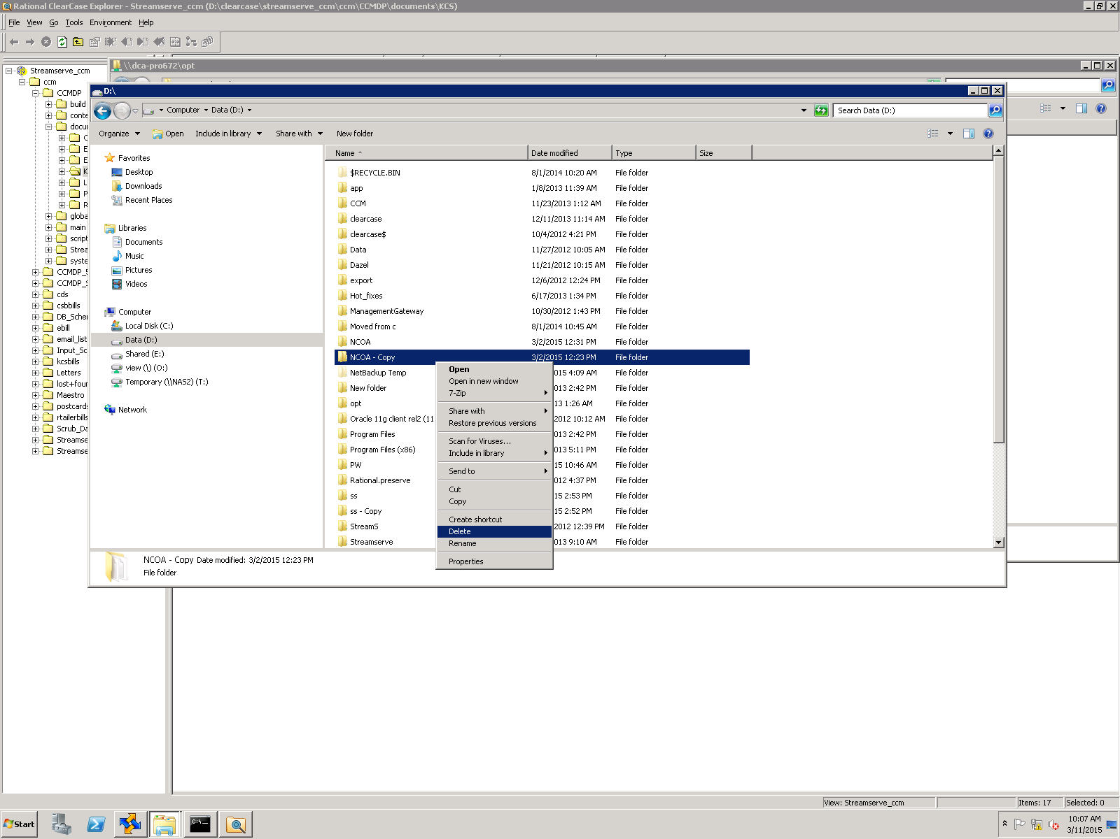

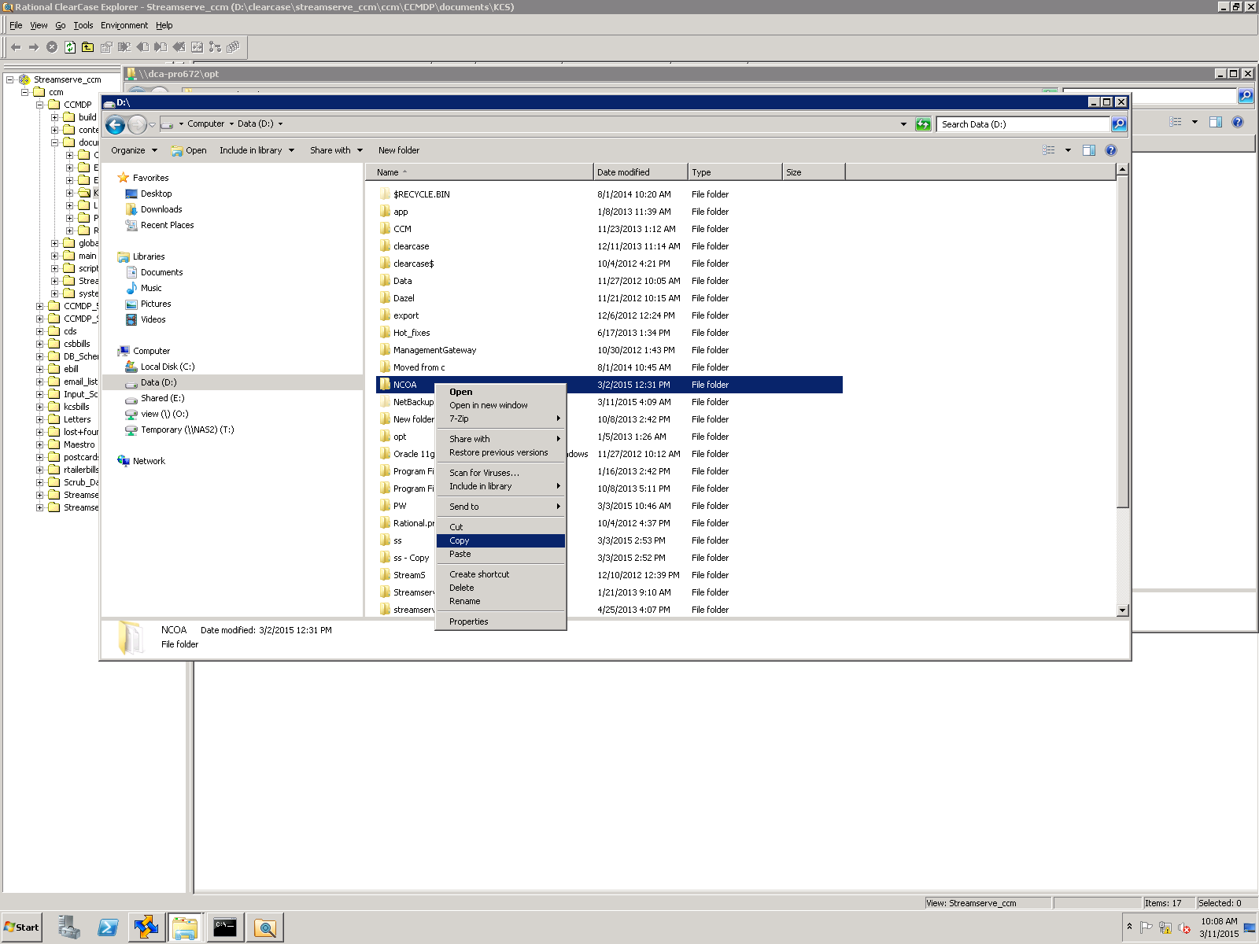

Copy the files from your local Folder and paste in D:\Program Files (x86)\SAP BusinessObjects\Data Services\DataQuality\reference_data folder

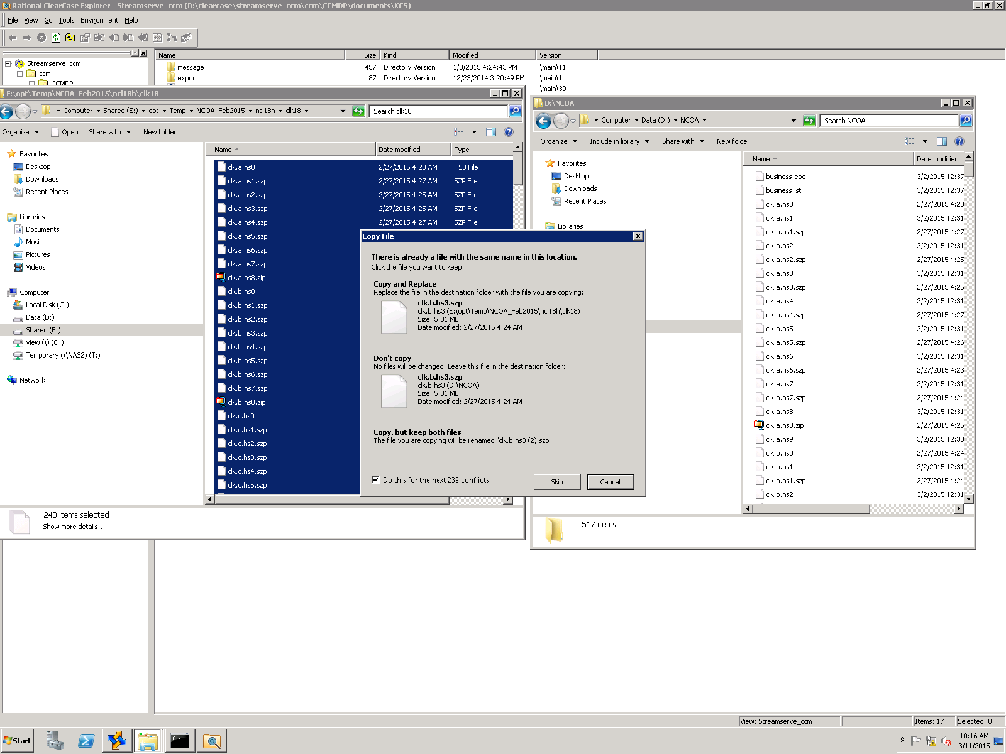

Open the D:\PW\ncoalink

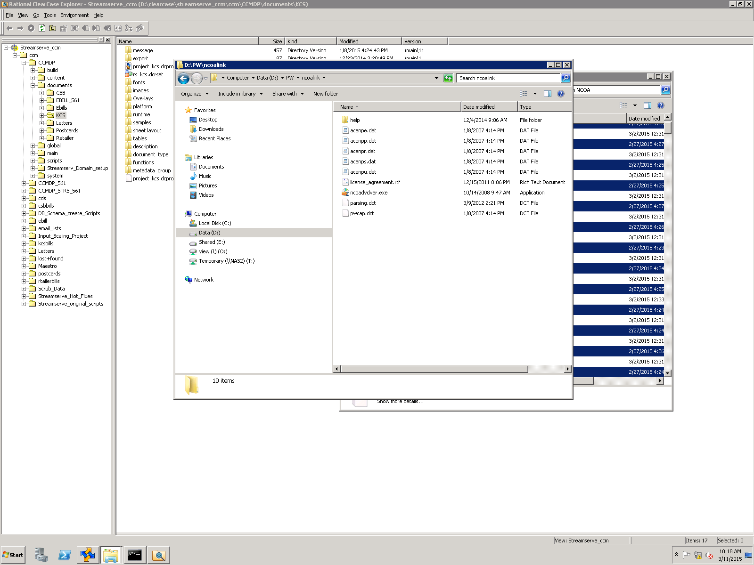

Click on ncoadvdver.exe to verification

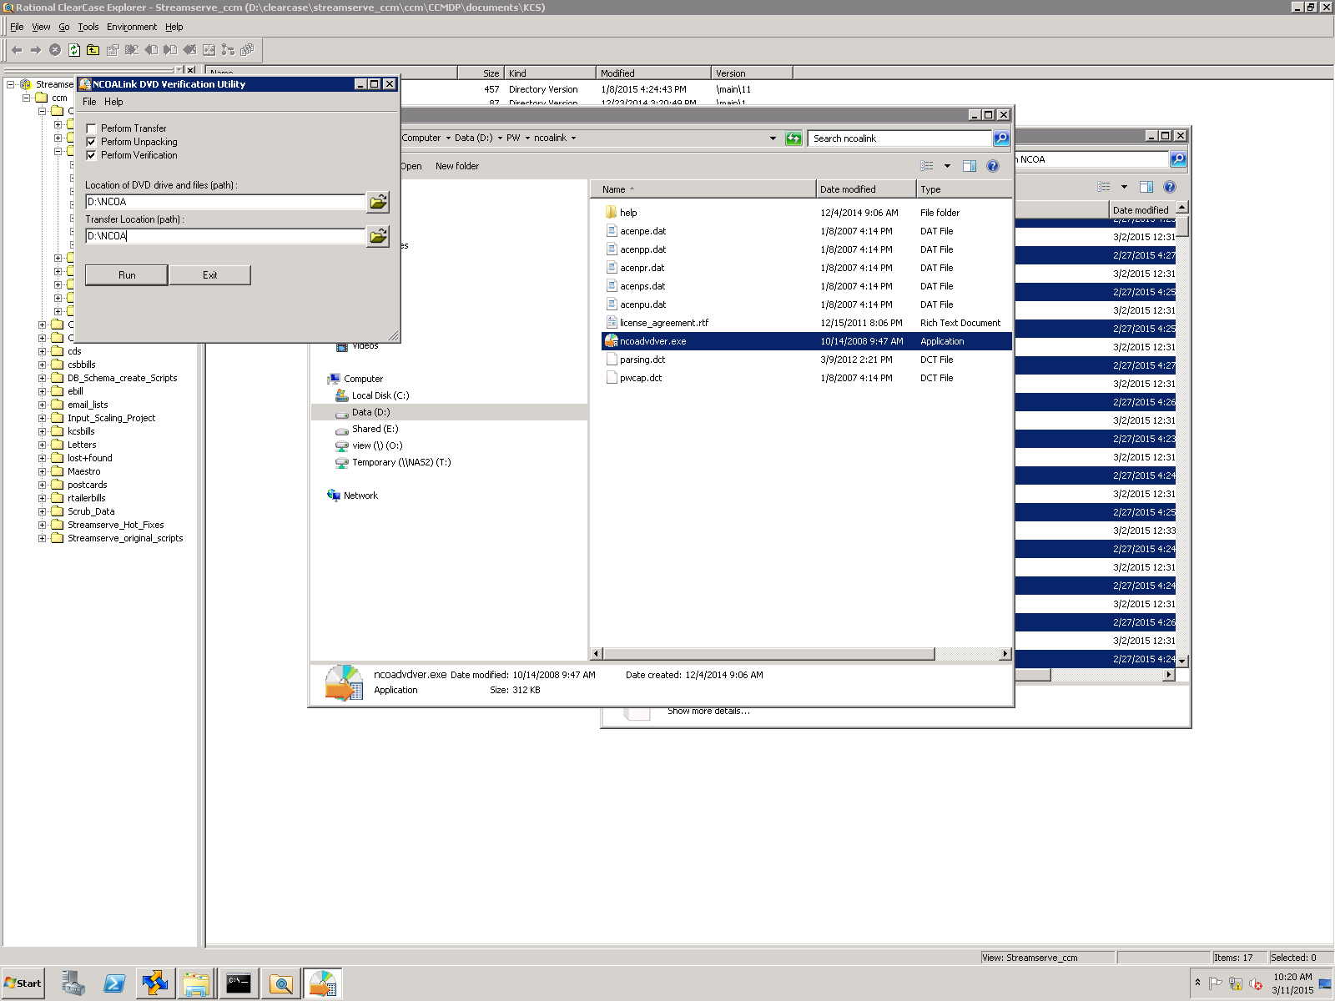

Follow the below doc fill up the columns and Click run.It should run successfully

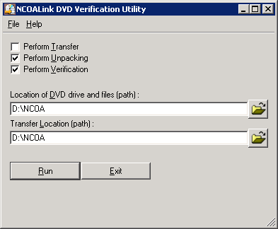

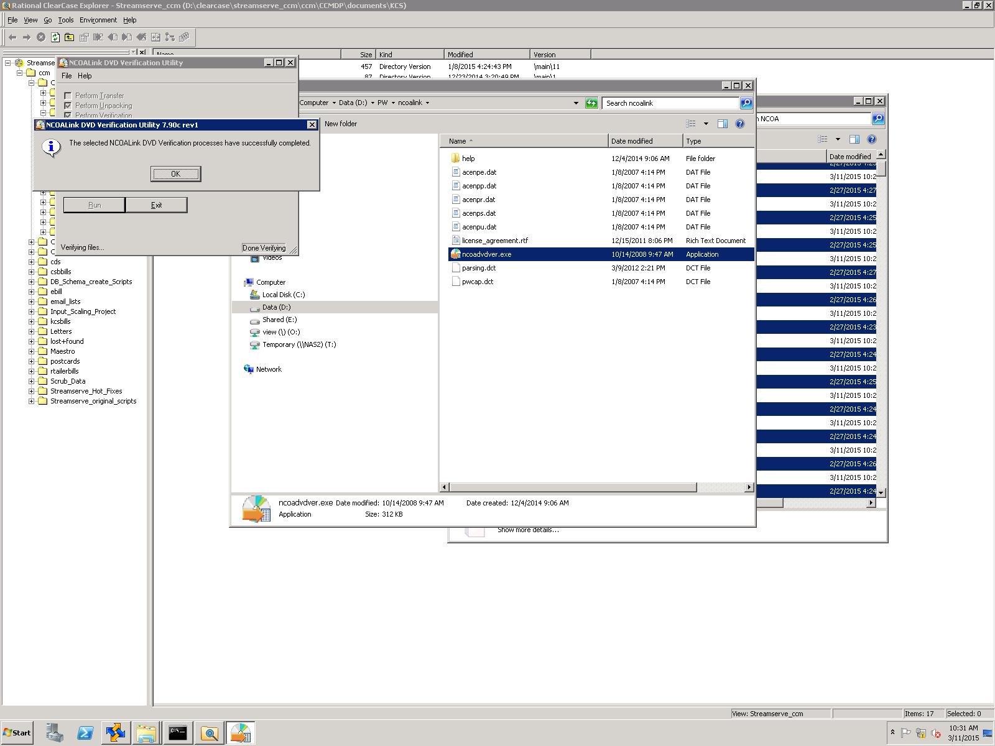

Login to DCA-DEV1121 and go to D:\Program Files (x86)\SAP BusinessObjects\Data Services\DataQuality\reference_data. Delete old NCOA-Copy. Make the copy of the latest NCOA.

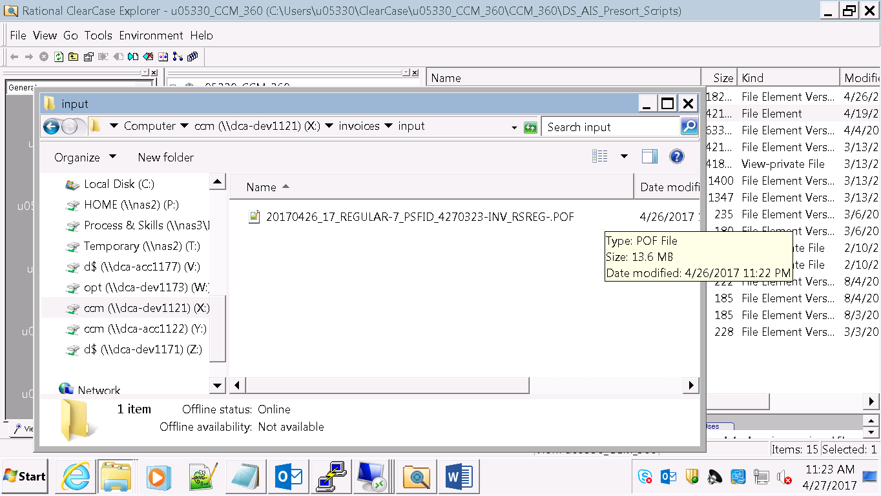

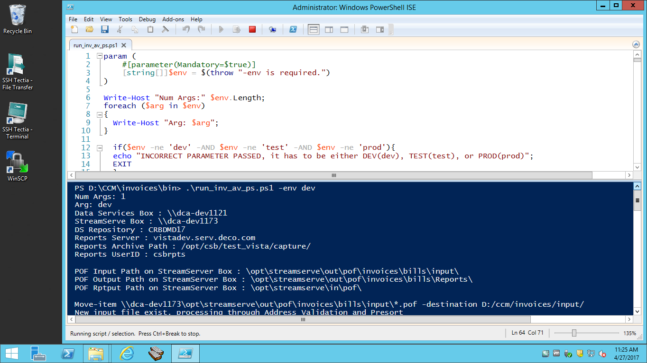

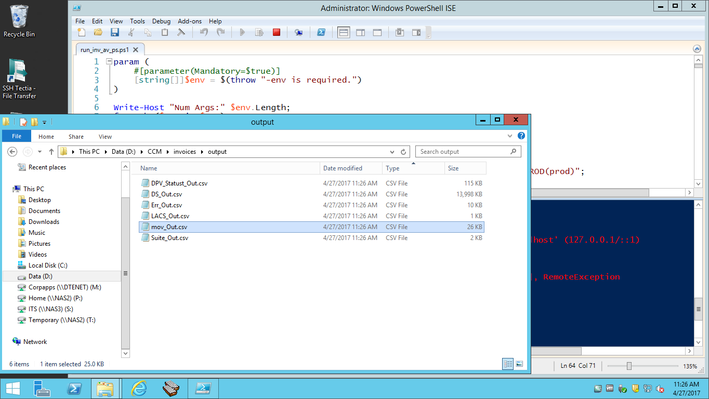

We should see the above file is more than 0 bites. Our test for NCOA is complete. We need to send an email to David Kaledas to deploy the NCOA directory on other boxes in DEV and QA environments. Once successfully tested in QA, we can create a CMR to have this deployed in PROD.